Petrel Plug-in for Declustering
and Debiasing
Version 2.0.0

January 15, 2008

Chad Neufeld and Clayton V. Deutsch

Centre for Computational Geostatistics
3-133 Markin/CNRL Natural Resources Engineering Facility (NREF)
University of Alberta
Edmonton, Alberta, Canada T6G 2W2

Installing the PlugIns
The plugins are installed using an MSI installer and a setup.exe file. The installer copies all of the required files to the target system. The required files include: (1) files required for the plugin and (2) files that the plugin requires to run. The installer will also modify the Petrel configuration file. An additional setup.exe file needs to be passed out with the MSI file. The setup.exe file installs the windows prerequisites that are required before the MSI file can be run. If the setup.exe file is run. It will automatically call the MSI installer when it has finished. The .msi file and the setup.exe file have been combined into a single installer. Running the installer will automatically decompress the setup.exe and .msi files and run the setup.exe file. Once the setup.exe file has finished, the .msi file will run.
The installer checks that Petrel 2007 is installed before it will install any files. It does this by checking that the OCEAN2007HOME environment variable is set. This is set by Petrel 2007 when it is installed. Ocean 2007 does not need to be installed on the target system for running the plugins. Ocean 2007 is only required to develop plugins. The installer will report an error if the OCEAN2007HOME environment variable is not set.
Future updates will be easy to install. The MSI installer will automatically detect the current version of the plugin and install the updates if required. There will be no manual steps for plugin upgrades.

Plugin Status
Currently 2 plugins have been written and tested. They include:
- Cell Declustering, and
- Bi-variate debiasing,
All of the plugins have been tested and run from the process dialog and the workflow manager. A test petrel project may be available in the future.

Known Issues
There are currently no known issues with the Ocean interface to Petrel. The only quirk has to do with the Function display window and its limits. The limits do not refresh automatically when displaying an XY function. Some of our domain objects are XY functions.
This issue arises when multiple custom objects are visualized. The first time any one objet is visualized, it will display correctly. When the first object is turned off and a second object turned on, the second object will display correctly. However, when the second object is turned off and the first object turned back on, the limits in the function window are not reset to the first object. They remain set for the second object.
The workaround is to click on the “include origin” button twice; once to select it and once to deselect it. This will reset the plot limits so that the current function can be visualized.

Using Declustering or Debiasing results with Petrel’s Petrophysical Modeling
The Ocean API does not allow access to Petrel’s function data type. This means that we cannot directly create a function that can be used as part of the petrophysical modeling workflow. There is a way that we can use the results though. Here are the steps that are required to use the declustering or debiasing results in simulation inside of petrel:
- Run the declustering or debiasing inside of Petrel
- Right click on one of the declustering/debiasing objects
- Choose export
- Choose the file name and where you want to save the file
- Import the file you just exported as a Function (X/Y)
- Use the imported function as a General Distribution in the petrophysical modeling workflow.

Plugin Description
All of the plugins described here can be accessed via can be accessed via the Processes tab or from a workflow editor. The interfaces to the plugins look and act very similar to the native petrel interfaces. To be consistent with Petrel, the plugins cannot create new objects when run from a workflow. The plugin has to be run as a process first, and then the output objects can be updated from a workflow. This will make updates with additional data very easy.
A decision was made to work exclusively with pillar grid properties. This means that all of the data must be transformed to an active 3D pillar grid. Petrel includes tools to facilitate this. Any point data can be upscaled to the grid and will be coded as Upscaled Grid Properties. Any secondary data can also be transformed to the grid with petrel utilities. Depending on the type of the secondary data, it may or may not be upscaled.

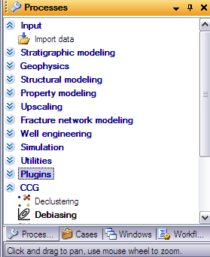

Cell Declustering
Clustered samples can result in biased distributions. Cell declustering is a common approach to correct for spatially clustered samples. This plugin implements the GSLIB version of cell declustering.
The input to the plugin is an upscaled pillar grid property. If no upscaled cells are present, the status textbox will display “not upscaled.” There is an option to update an existing declustering object or to create a new object by specifying a name. The parameters for the declustering are exactly the same as the parameters for the command line cell declustering. You need to specify the Y/X and Z/X cell anisotropies, the range of cell sizes, the number of cell sizes and the number of origin offsets. In addition, the plugin needs to know what optimal cell size to use for the declustering. You can tell the plugin to keep the cell size that provides the minimum mean, or the maximum mean, or you can input a specified target cell size. If a specified cell size is given, the range of cell sizes will still be run, but the weights will be determined using the specified cell size.
The output from the cell declustering is saved in a custom domain object. The domain object is saved at the end of the input tree and contains the original CDF, the declustered CDF and a summary plot of the declustered mean versus cell size. The declustered CDF has the cell size appended to its name and it is also written in its comment. You can use the function window to visualize any child object of the declustering output object. There is currently no way to add anything to the legend area of a function plot. You can change the function line color by changing the color in the CDF settings page.
The declustering objects can be deleted by right-clicking on the object to delete and selecting “delete” from the context menu. Note that you have to click on delete. You cannot use the up or down arrow and the enter button.
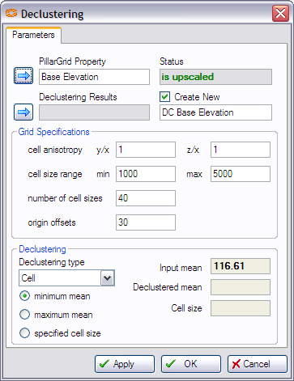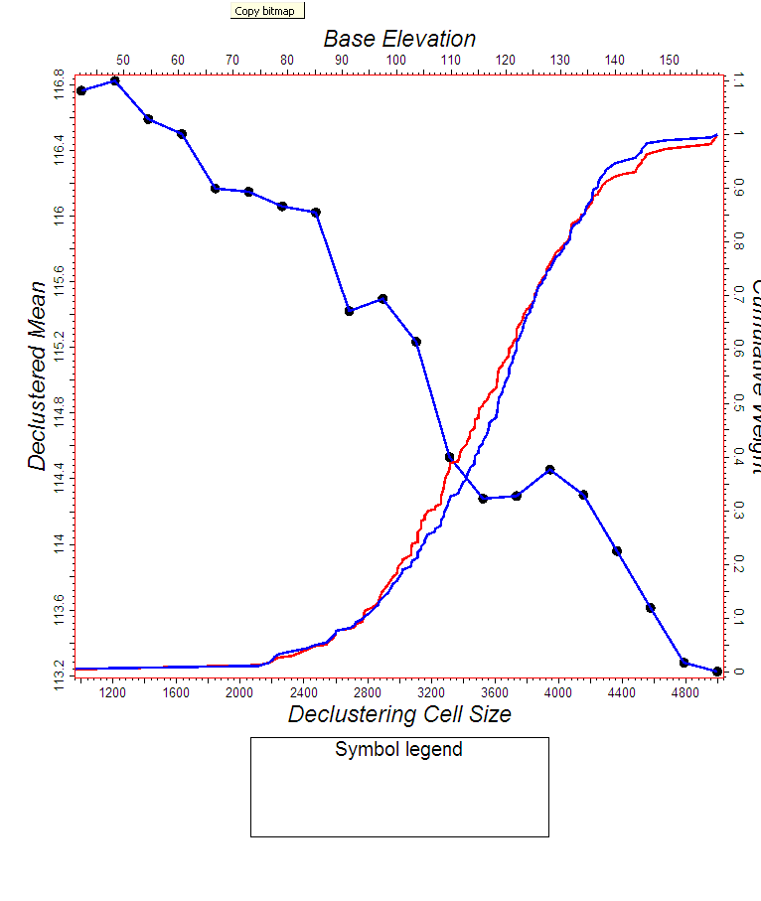

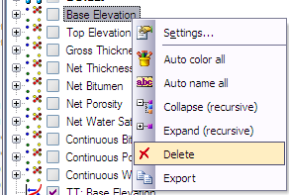

Bi-variate Debiasing
With many wells, cell declustering can be used. However, with limited well debiasing is a more feasible alternative.
The input to the debiasing plug-in is two pillar grid properties. The first property is the primary variable; e.g. porosity. The second property is the densely sampled secondary variable. After the 2 variables have been chose, the debiasing parameters need to be chosen. These parameter relate to the x- and y-axis discretization. There are 4 debiasing methods available: (1) non-parametric, (2) bi-variate (log)normal, (3) conditional (log) normal, and (4) user-specified quantiles. The input parameters in the lower window change depending on which debiasing method is chosen. Please refer to the attached paper, Deutsch and Does. Programs for Debiasing and Cloud Transformation, for details on the different debiasing methods.
The output from the debiasing is saved in a custom domain object. The domain object is saved at the end of the input tree and contains the original CDF, the debaised CDF and a summary plot showing the data pairs and the calculated bi-variate CDF. You can use the function window to visualize any child object of the debiasing output object. There is currently no way to add anything to the legend area of a function plot. You can change the function line color by changing the color in the CDF settings page.
The declustering objects can be deleted by right-clicking on the object to delete and selecting “delete” from the context menu. Note that you have to click on delete. You cannot use the up or down arrow and the enter button.

